**Workshop on Data Science: Trends, Forecasts & Challenges**

**August 10 to 16, 2020, 2:00 pm to 4:00 pm**

**Speaker Profile& Schedule**

The Global Data Science Market has witnessed strong, continuous growth in the past few years and is projected to continue this same path. With the help of data science, organizations can now leverage data to extract valuable insights, which are used to create actionable decisions. In the past few years, it has been broadly used to empower organizations to make the most profitable business choices.

Shri Vaishnav Institute of Technology of Shri Vaishnav Vidyapeeth Vishwavidyalaya, Indore has proposed to conduct one week online “Workshop on Data Science: Trends, Forecasts & Challenges” from August 10 to 16, 2020, 2:00 pm to 4:00 pm.



Dr. Abhishek Singh Rathore

Associate Professor, Dept of CSE, Shri Vaishnav Vidyapeeth Vishwavidyalaya, Indore

Topic: Introduction to Data Science & Forecasting

Date & Time: 10 Aug 2020 2:00 PM to 4:00 PM

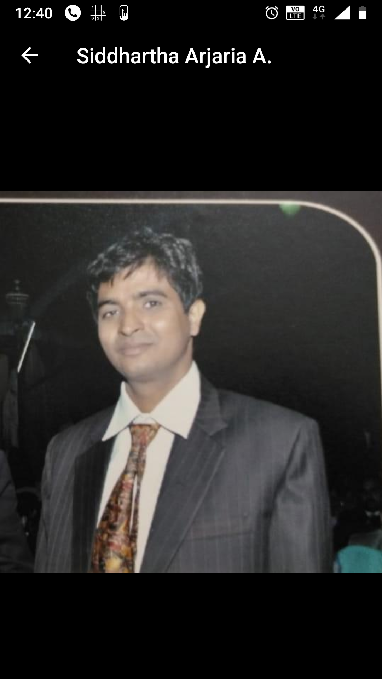

Dr. SiddharthArjaria

Assistant Professor, Dept of IT, Rajkiya Engineering College, Banda

Topic: Hands on Data Analysis

Date & Time: 11 Aug 2020 2:00 PM to 4:00 PM

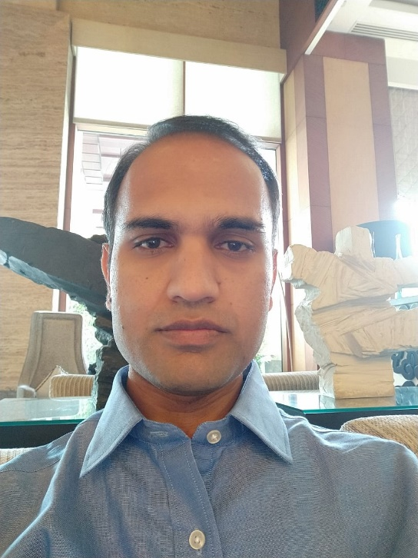

Mr. BrajeshParwal

Project Manager, Accenture.

AWS Solution Architect, Data Architect, Automation Architect, PMP Certified

Topic: **DevOps – How to measure Success**

Date & Time: 12 Aug 2020 2:00 PM to 4:00 PM

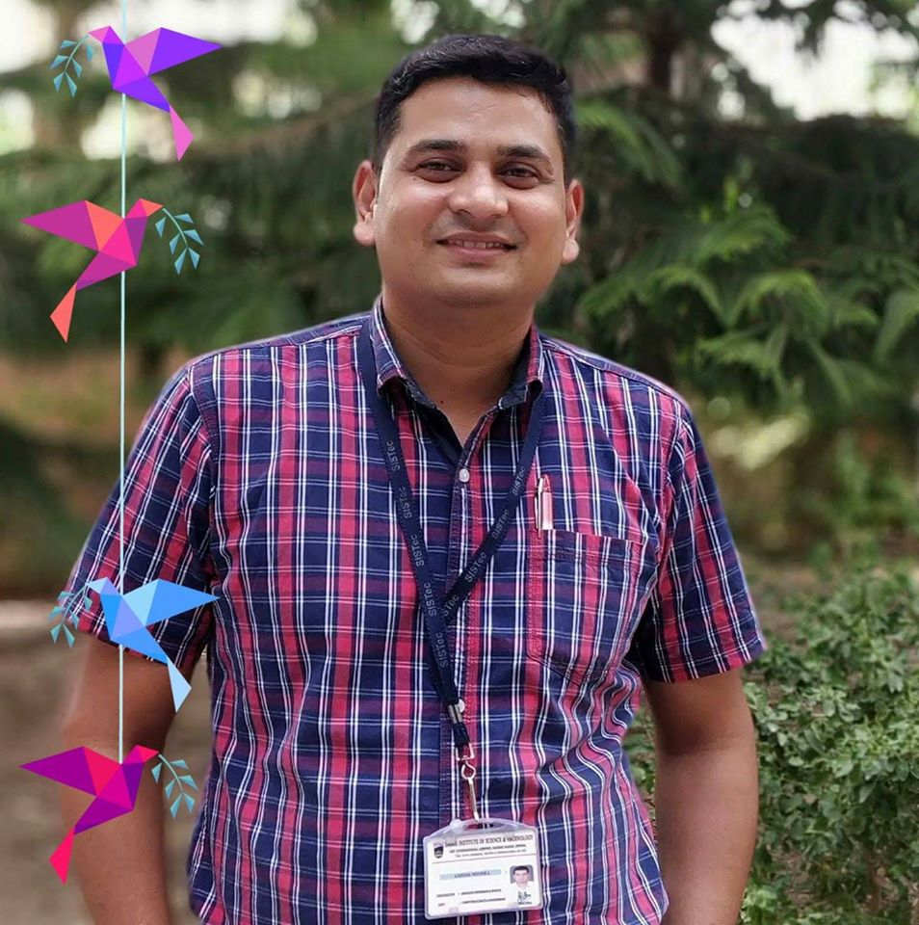

Dr. Ashish Mishra

Assistant Professor, JIIT, Noida

Topic: GPGPU: High Performance Computing for Data Science

Date & Time: 13 Aug 2020 2:00 PM to 4:00 PM

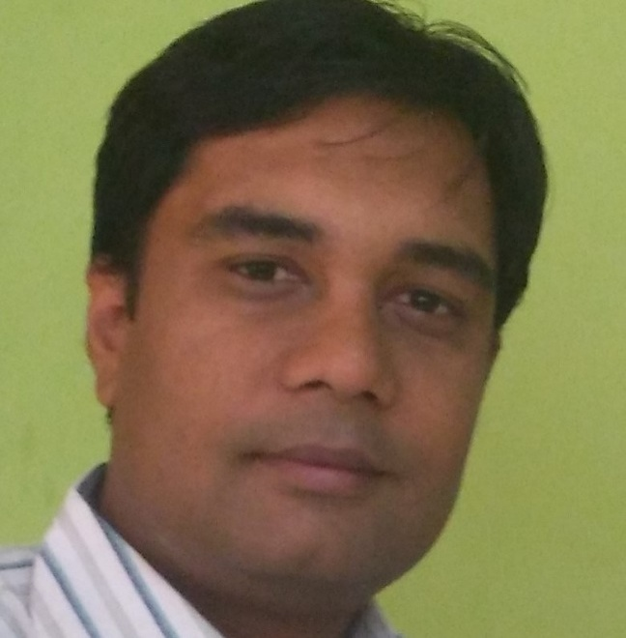

Dr. Harshvardhan Tiwari

CIIRC, Bangluru

Topic: EDA: Insight to Dataset

Date & Time: 14 Aug 2020 2:00 PM to 4:00 PM

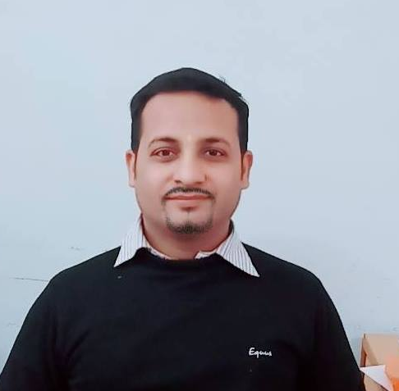

Dr. Anand Singh Rajawat

Assistant Professor, Dept of CSE, Shri Vaishnav Vidyapeeth Vishwavidyalaya, Indore

Topic: BioPython

Date & Time: 15 Aug 2020 2:00 PM to 4:00 PM

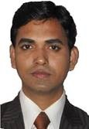Dr. JayendraBarua

Assistant Professor, Dept of CSE, Shri Vaishnav Vidyapeeth Vishwavidyalaya, Indore

Topic: Tools and Techniques for NLP

Date & Time: 16 Aug 2020 2:00 PM to 4:00 PM

Fees Detail: 200 Rs / 100 Rs. For SVVV Members

Bank Detail.-

Registration Link-https://docs.google.com/forms/d/e/1FAIpQLScvRJ4BI0nGjL_NO3oblWag68lxPa94cgfoozivmeHvYkL7Ew/viewform?usp=sf_link

Kindly Mention Data Science Workshop in comments.